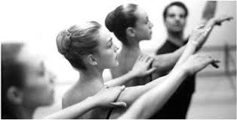
Back to Ballet Basics
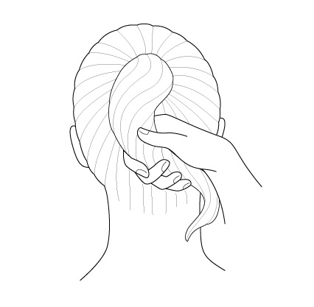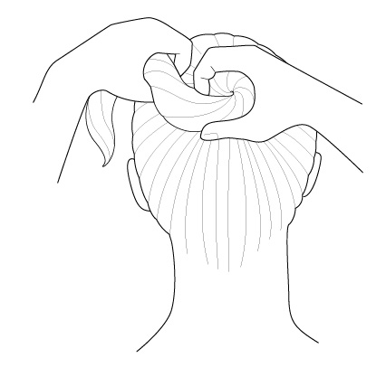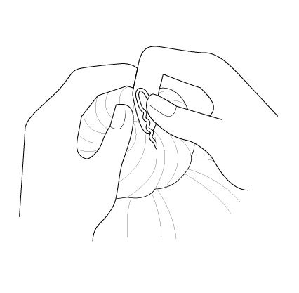
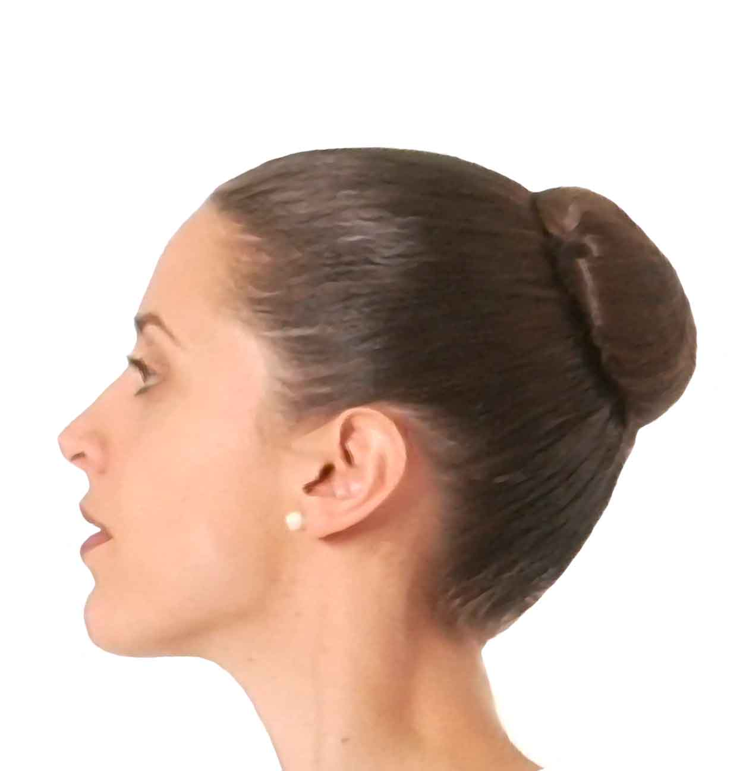
How to do a Ballet Bun
1. Gather hair up and use a secure elastic band to make a tight ponytail.
2. Twist the ponytail itself and then coil it around the elastic band making at least one complete circle; tuck the end of the ponytail under the bun and hold everything in place with your hand.
3. Place the hair net around the bun, wrapping it as many times as necessary to secure it completely. If the bun sticks up too high, flatten it with your hand and use pins to flatten it down so that the bun top is closer to your head and forms a smoother line.
4. Use large hair pins around the bun to secure the bun. Insert the pins in a loop away from the bun and tuck underneath.
See video demonstration at https://www.youtube.com/watch?v=16pMFAt13TU
5. Use bobby pins and hairspray to tidy any wisps.
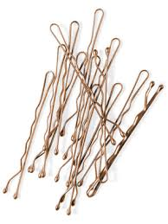
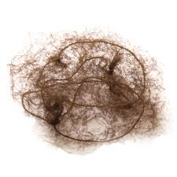
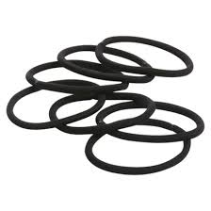

You can purchase hair nets and hair pins from most hot dollars/dollar stores/discount shops. Make sure you look for bun pins (not fringe pins) and hair nets, which is ideal for long hair as you can wrap around the bun a few times.

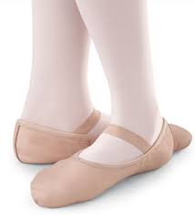
How to sew elastics on ballet shoes:

- Fold down the back of the shoe and mark a line with a pencil where the fold meets the edge.
- Measure the length of elastic needed with a pencil when the shoe i
- Pinch the canvas as not to stitch through the entire shoe, but only the inside lining.

